**Project Title**

**1. Introduction**

Deputies Relief Fund Inc. of Harris County, Texas (Non for profit organization).

**2. Design and Implementation**

* My website will include the following three potential pages:

1. Index.html
2. Gallery.html
3. Donation.html
4. Admin Login (did not create this dashboard yet)

* The index.html page will include the following 5 sections within the one page:

1. Home page
2. About Us
3. Our purpose
4. Board of Directors
5. Contact Us

* This page will include an external CSS and J-script file.
* One of the designs I’ve attempted to incorporate into my website was a responsive background video of the American flag flowing in the air. Unfortunately, this was very difficult and as a result, I decided to include a “gif” photo of the American flag instead. I did this by converting the video I previously wanted to use into a “gif” (animated picture file). I used “<https://ezgif.com/video-to-gif>” to convert the video and I was able to code the background “gif” by implementing the following code into my css file:

background: linear-gradient(to bottom, rgba(0, 0, 0, 0.3) 0%, rgba(0, 0, 0, 0.7) 95%, #000000 100%), url("../assets/img/flagofusa.gif");

* My website started off as a templet, but I have included many of what we have learned within our class such as the responsive Navbar, the Carousel, The modal (which will be function through jQuery as soon as I get the chance), external pages with a-href’s, and the list goes on. I do plan on adding a Dashboard for Deputies Relief fund as I do not want to manage their site. I also plan on including a form to collect contact info whenever a person inputs their email to obtain updated information.
* Here are a few screenshots of the unfinished website:

Home page section:

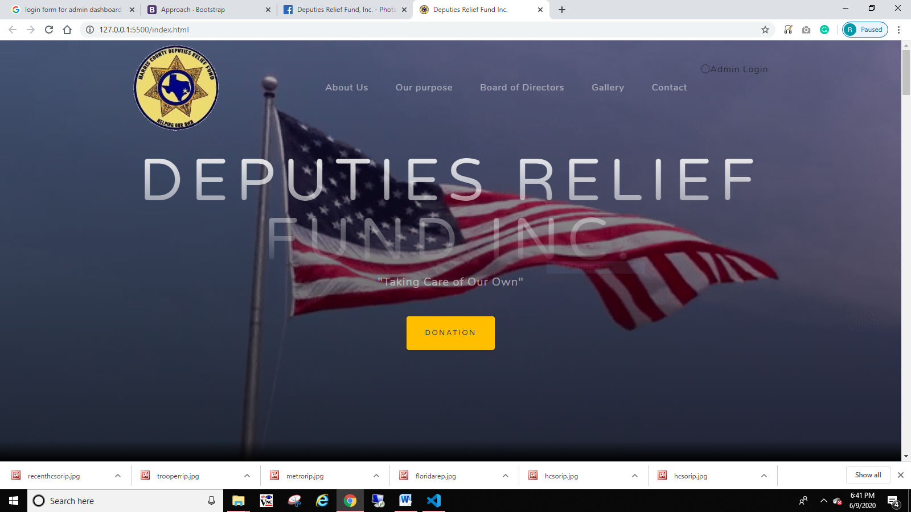

About Us section:

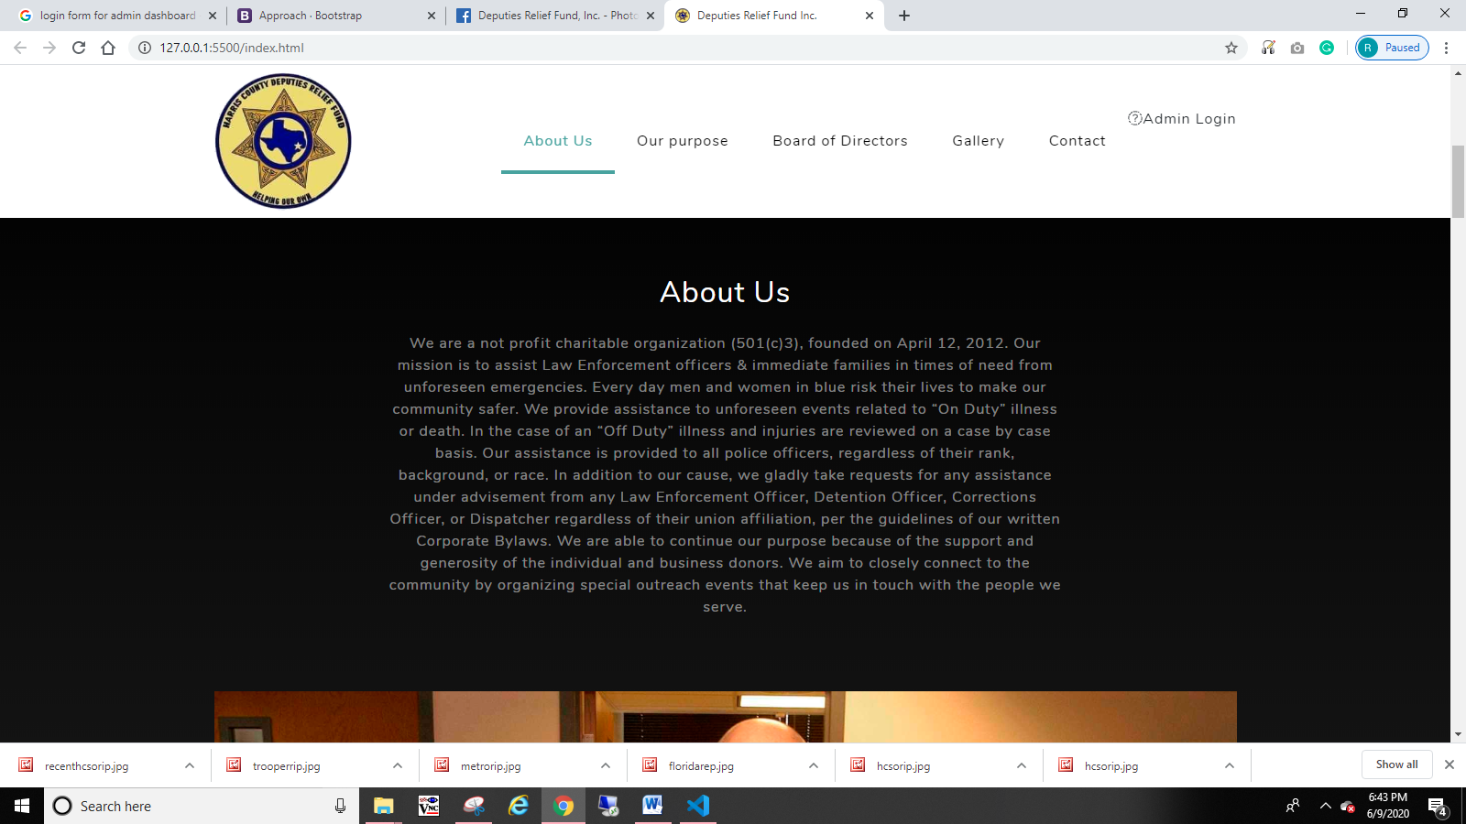

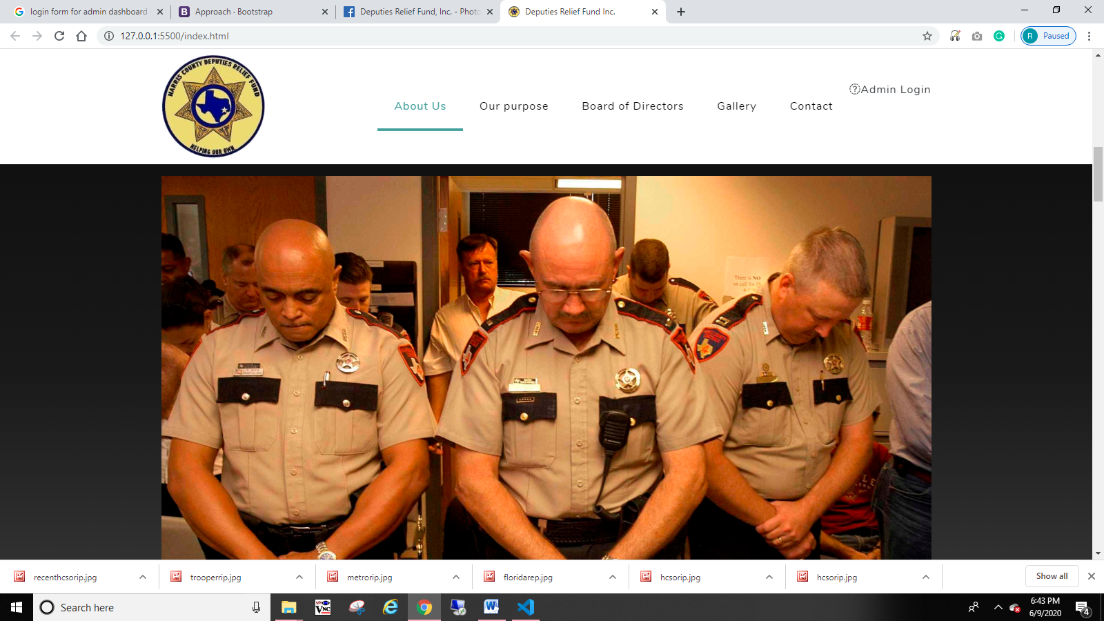

Our Purpose section:

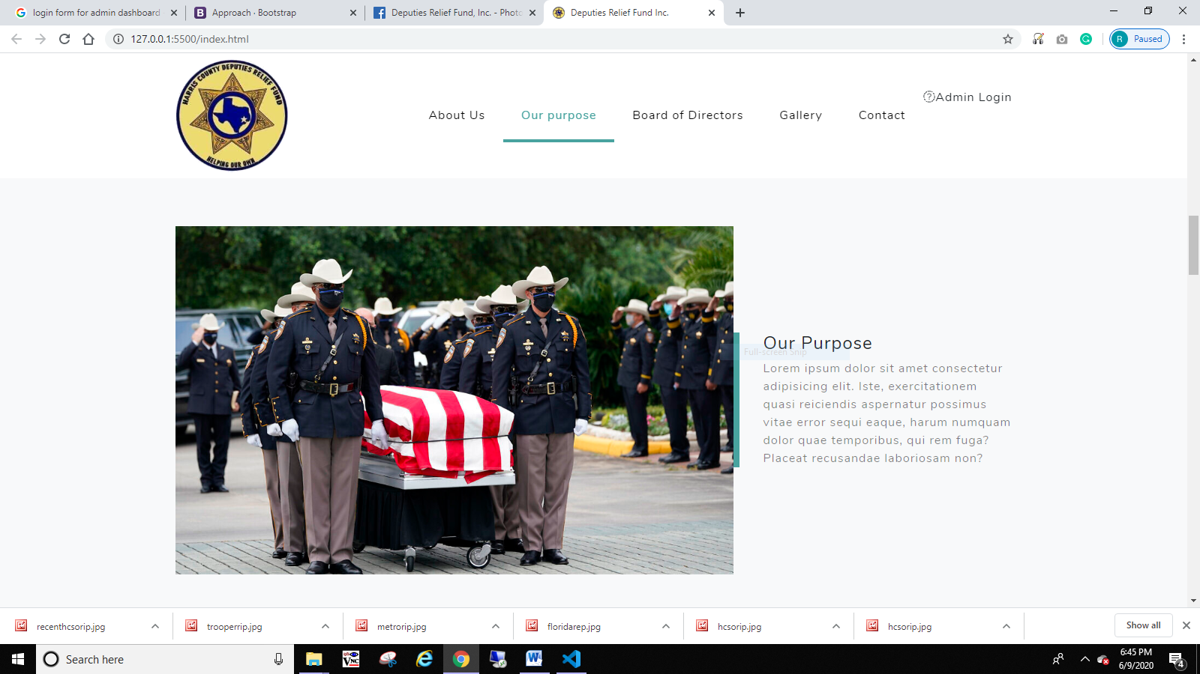

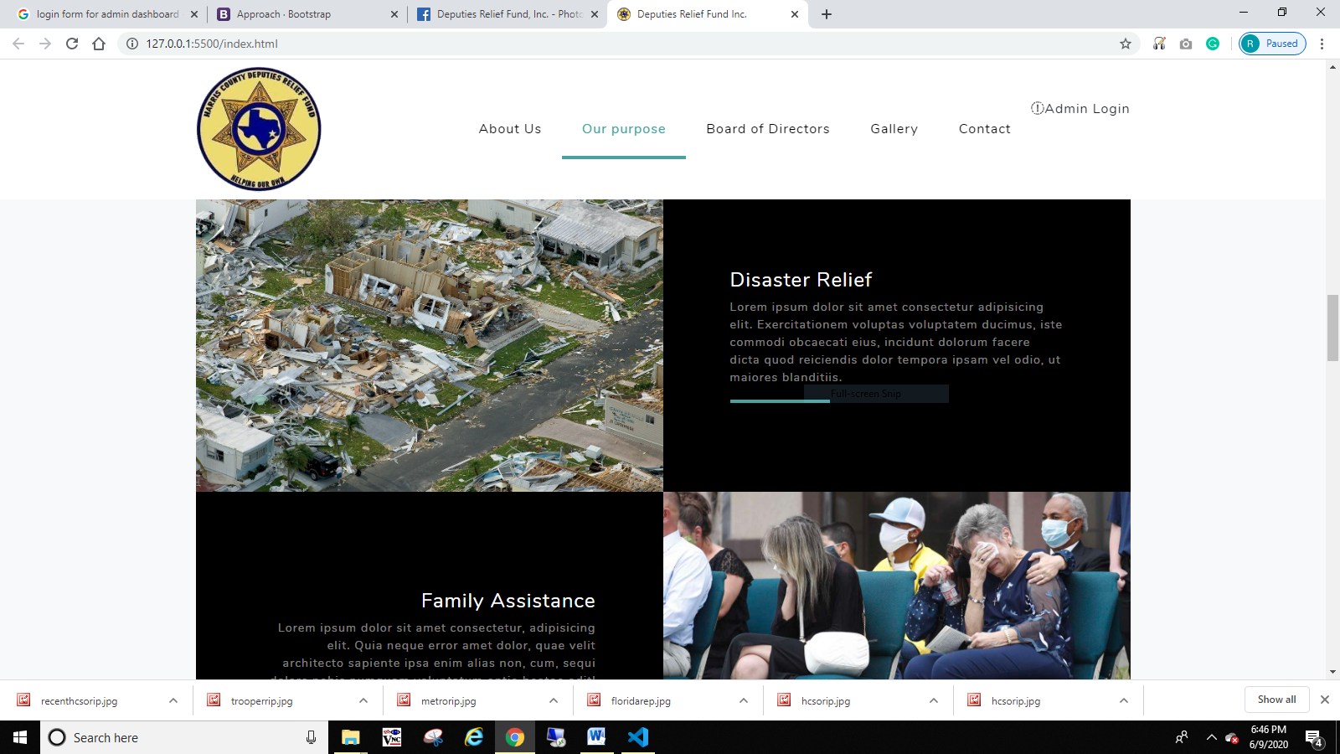

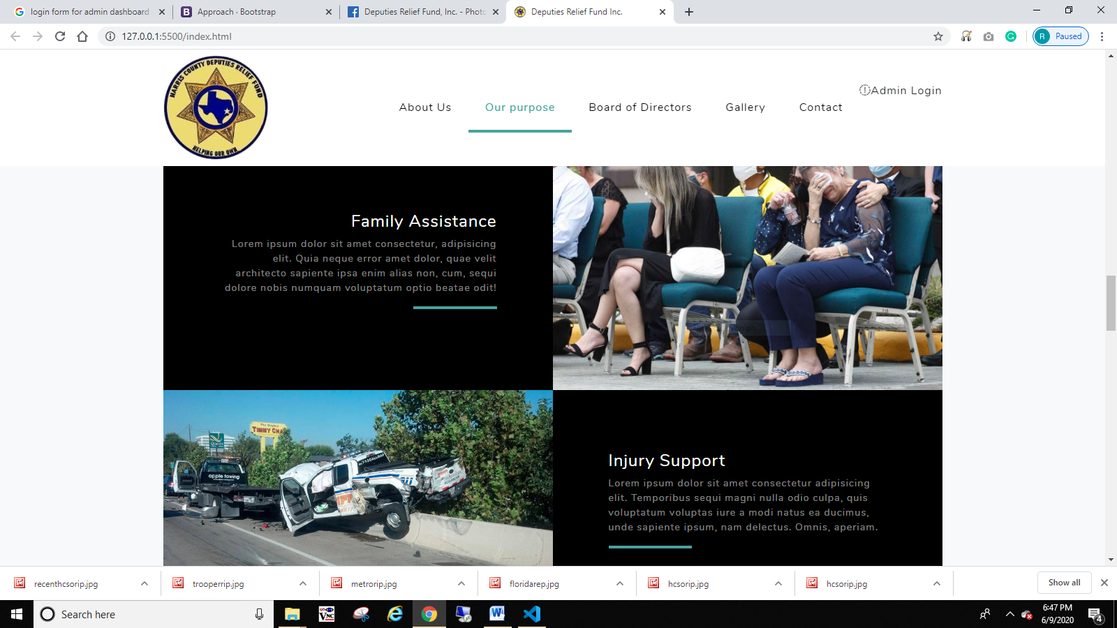

Board of directors section:

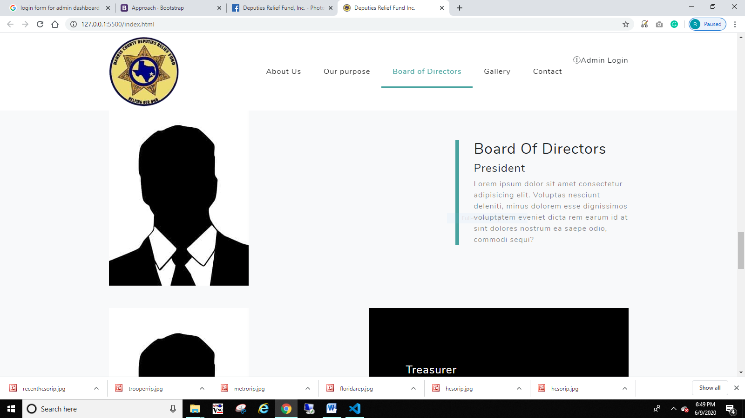

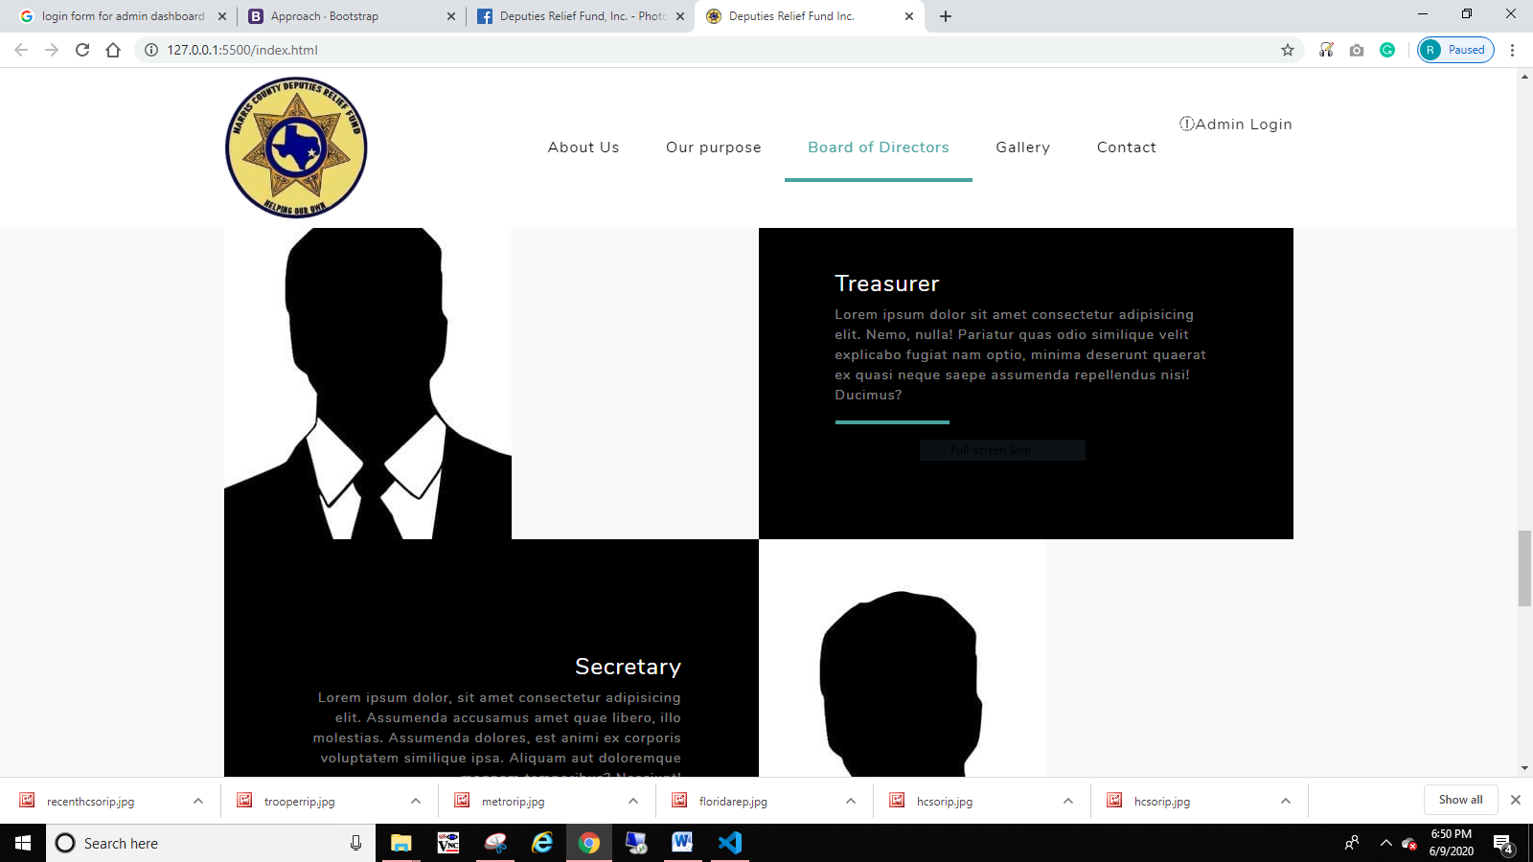

Gallery Carousel page:

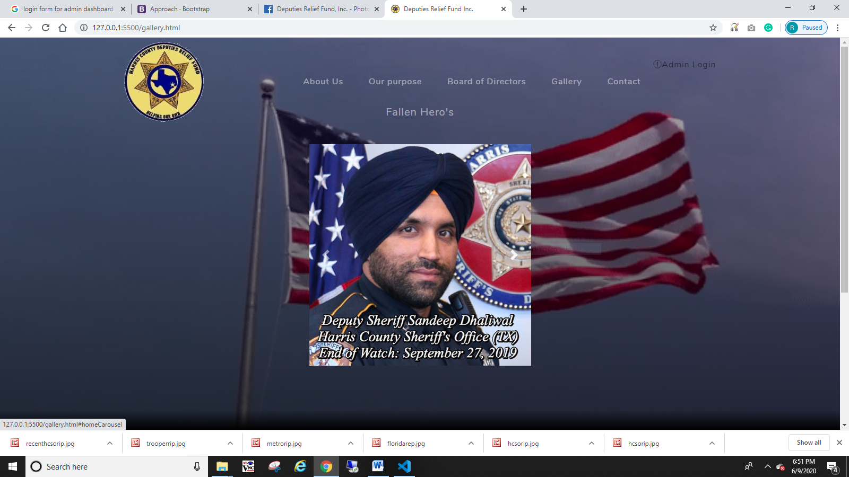

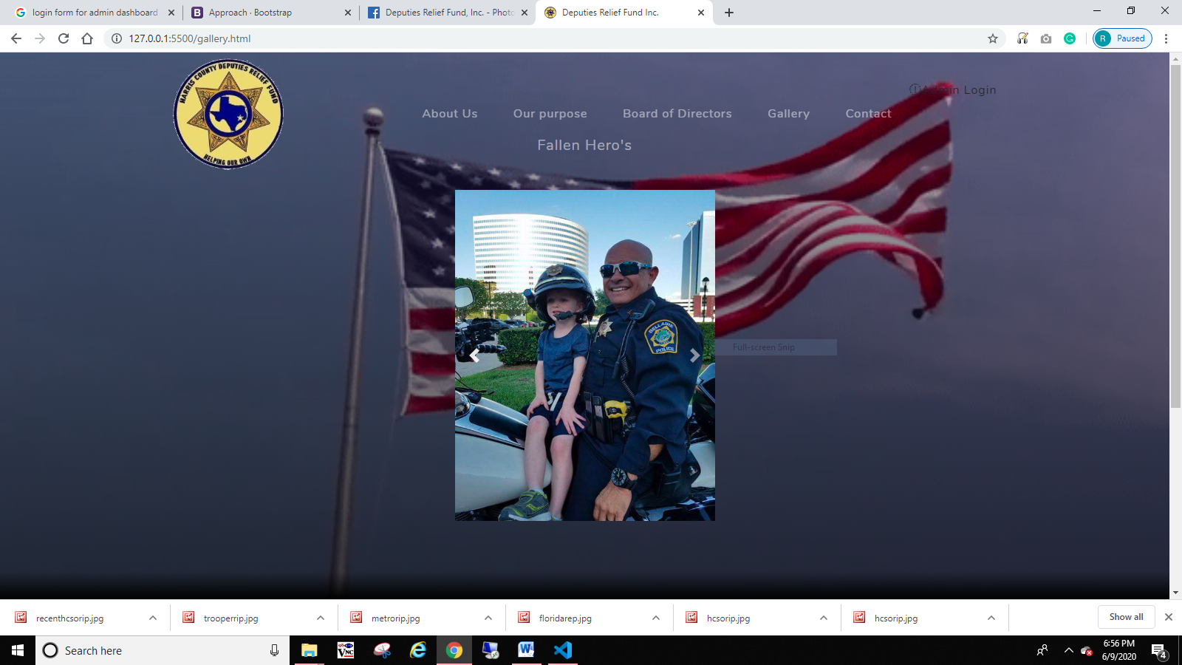

Contact Us section:

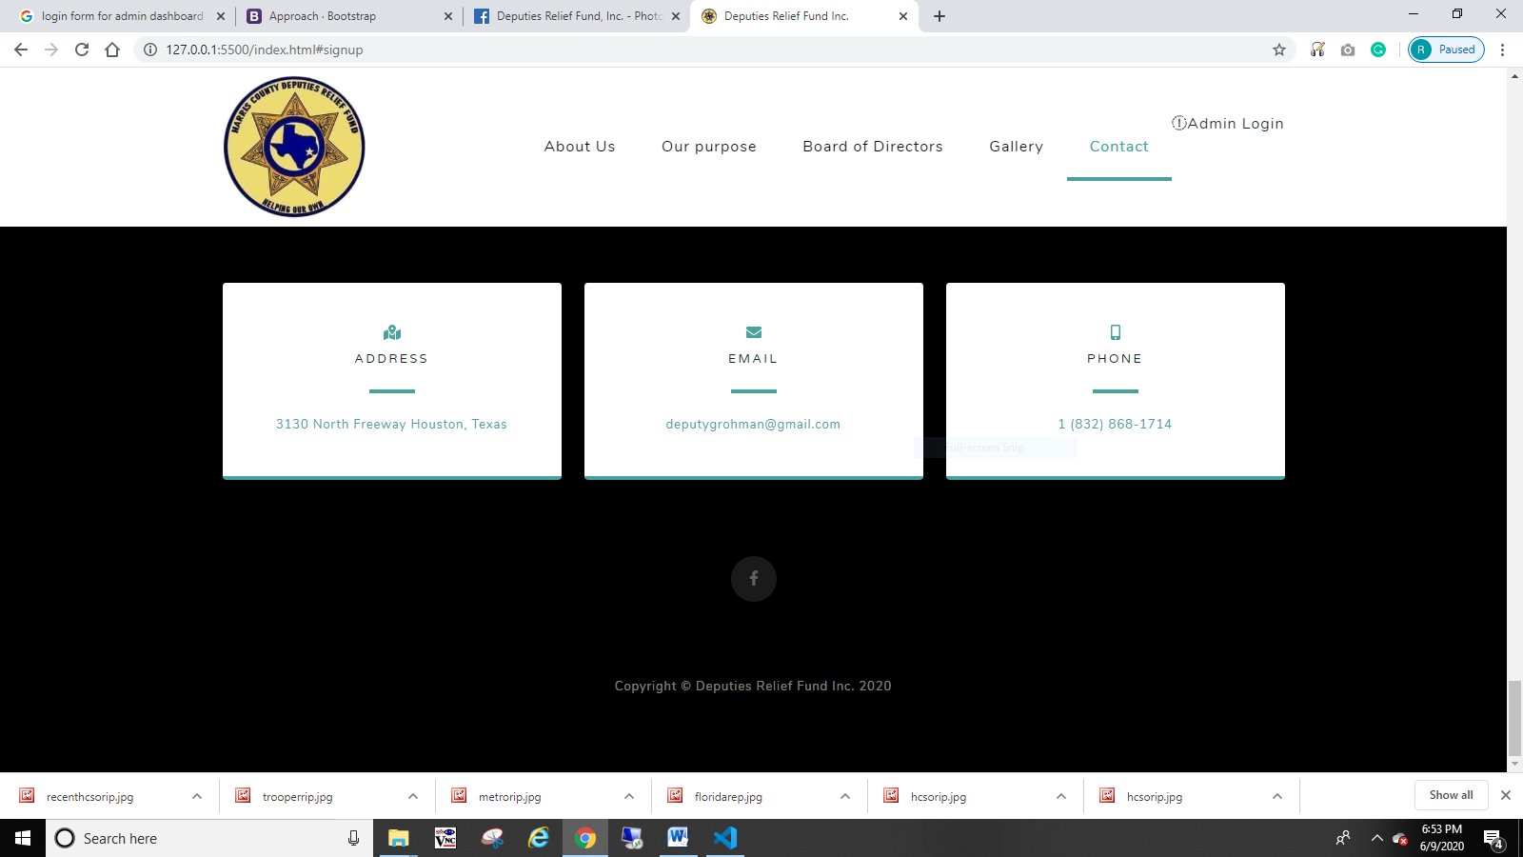

Donation page:

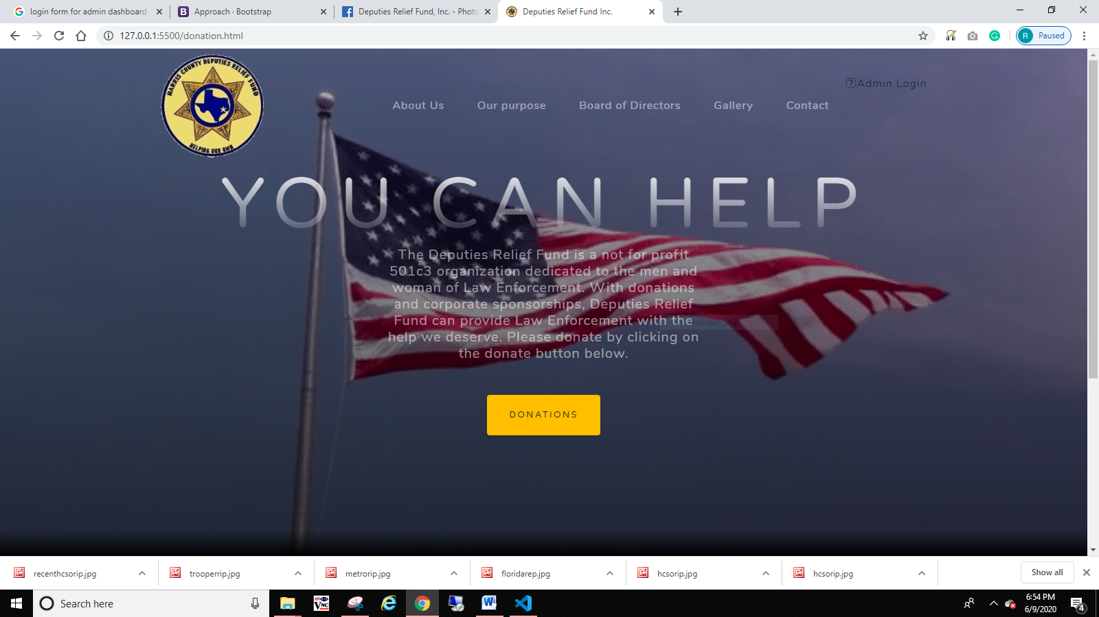

**3. Conclusions**

* I’ve learned a little more jQuery doing this project.
* The biggest shortcoming I’m faced with at this time is the lack of website Content I’m currently waiting on from the president of Deputies Relief Fund Inc.
* In the future I will advise the client that content information is mandatory before starting on their website.